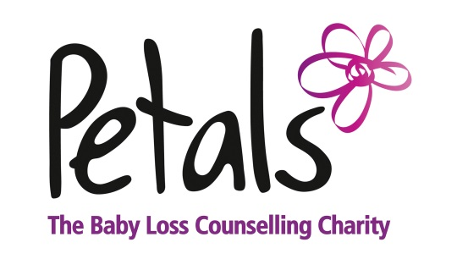

Gift Aid declaration

Name of charity: PETALS

In order to Gift Aid your donation you must tick the box below.

I want to Gift Aid any donation I make in the future or have made in the past 4
years to Petals.

I am a UK taxpayer and understand that if I pay less Income Tax and/or Capital Gains Tax than the amount of Gift Aid claimed on all my donation in that tax year it is my responsibility to pay the difference.

Donor’s details

Title ------------- First name or initial(s) --------------------------------------------------------------------------

Surname --------------------------------------------------------------------------------------------------------------

Full Home address ------------------------------------------------------------------------------------------------- -

--------------------------------------------------------------------------------------------------------------------------- Postcode ----------------------------------

Date ------------------------------------------------------------------------

Signature ---------------------------------------------------------------- (can be electronic)

Please notify the charity or if you:

• Want to cancel this declaration
• Change your name or home address
• No longer pay sufficient tax on your income and/or capital gains.

If you pay Income Tax at the higher or additional rate and want to receive the additional tax relief due to you, you must include all your Gift Aid donations on your Self-Assessment tax return or ask HM Revenue and Customs to adjust your tax code.

Registered Charity No. 1150375

